Abstract

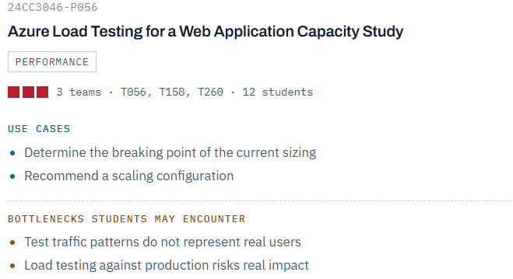

Abstract
The project “Azure Load Testing for a Web Application Capacity Study” focuses on evaluating the performance, reliability, and scalability of a web application using Microsoft Azure cloud services.

The main objective is to determine the maximum workload that the current application configuration can handle before response time increases, errors occur, or system resources become heavily utilized.
In this project, a web application is deployed on Azure App Service and tested using Azure Load Testing. Different levels of simulated users and requests are generated to represent increasing application traffic. During each test, important performance parameters such as response time, requests per second, error percentage, CPU utilization, memory usage, and application availability are monitored using Azure monitoring tools.

┌─────────────────────────┐
│ Azure Load Testing │
│ │
│ Simulated Users/Traffic │
└────────────┬────────────┘
│
│ HTTP Requests
▼
┌─────────────────────────┐
│ Azure App Service │
│ │
│ Web Application │
│ │
│ Instance 1 │
│ Instance 2 │
│ Instance 3 ... │
└────────────┬────────────┘
│
▼
┌─────────────────────────┐
│ Azure Monitor / │
│ Application Insights │
│ │
│ CPU │
│ Memory │
│ Response Time │
│ Requests │
│ Errors │
└────────────┬────────────┘
│
▼
┌─────────────────────────┐
│ Azure Auto scale │
│ │
│ Scale Out │
│ Scale In │
└─────────────────────────┘

The testing process begins with a small number of users and gradually increases the workload. The results are analyzed to identify the application's breaking point, which is the traffic level at which the application no longer satisfies the predefined performance requirements. After identifying the bottleneck, Azure scaling features are configured to increase the number of application instances or resources when the workload increases.
The project also compares application performance before and after scaling. The final outcome provides a recommended Azure configuration based on measured performance rather than assumptions. The study helps demonstrate how cloud-based load testing and autoscaling can improve application availability, performance, and resource utilization.
For safety and reliability, load tests should preferably target a development/staging environment or deployment slot rather than a production system, because uncontrolled load testing against production can affect real users.

